Louis Riel – Red River and Formation of Manitoba
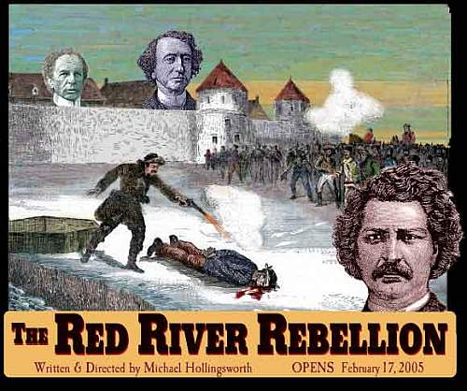
Name:
“If We Were Rebels” 13:06 – From Sea To Sea (Good to watch first 3 mins for intro on Riel)

- What year did Louis Riel abandon his studies? ____________

- “Metis” are half _________ and half __________.

- Who’s lease on Rupert’s Land is about to expire? ___________________.

- Win anticipation of the transfer of Rupert’s Land, who has been coming into the colony and why are they there?

______________________________________________________________________

- When did Riel arrive back in Red River? ___________

- For some time settlers have been plotting lots for future settlement; however, why is this a problem?
_______________________________________________________________________
- Riel decides to take a decisive and risky step by doing what next ?

_______________________________________________________________________
8. Riel establishes a ________________ Government for protection comprised equally of French and English.

“War is Upon Us” from Sea to Sea episode 3e4
20:19
- John A. MacDonald’s feels that the “half breeds are spoiled and must be kept down by a strong hand until absorbed by the settlers.” He then appoints a Lieutenant Governor to the area. This man is ________________________.

- He must travel through the United States to arrive to Red River, but who is waiting for him when he arrives?
_______________________
- What is controversial about McDougall reading the Proclamation on Canadian soil?
_________________________________________________________________________
- What does the Proclamation say? _____________________________________________
_________________________________________________________________________

- Riel then takes matters into his own hands and seizes _____________ and _____ (#) followers

and throws them into Fort Garry. He is soon named ______________ and _________________.

Riel is now in a good position to deal and negotiate with Ottawa, but path to negotiation is interrupted by a fateful decision.
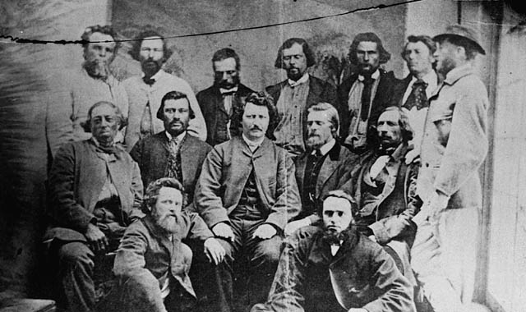
“A Single Act of Severity” 24:40 of Sea to Sea

- Who is threatening to kill Riel at Fort Garry? _________________

- In early March, riel appoints a tribunal to try Scott for citing violence against the Metis. What is the outcome of this trial?
________________________________.
- What “Single act of severity” occurred on March 4, 1870____________________________

- Despite the tensions, secret diplomacy is also underway and Métis negotiators arrive in

Ottawa to meet with _______________ and _________________.

- During these secret negotiations, the Métis spokesperson (Priest Richot) is determined to discuss:
- Full ________________________ status.

- ___________________ for all citizens.

- Provisions for ________________________for Catholics.

- ______ million acres of land is given to children of Métis.

- On ________, Manitoba is created and joins Confederation.

- Despite the success of the Manitoba Act, MacDonald decides not to grant Riel____________

- To appease Ontario, MacDonald then sends ______ British regulars and ______ volunteers to Red River to ensure the safe transfer of land.

- Colonel Wosley is sent to Red River and tensions escalate when volunteers run wild and set off a violent rampage that saw them

_____________________________________

