Canada’s A People’s History Name:
Post 7 Years War, James Murray, Sir Guy Carleton, Quebec Act
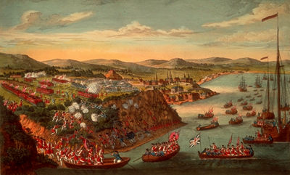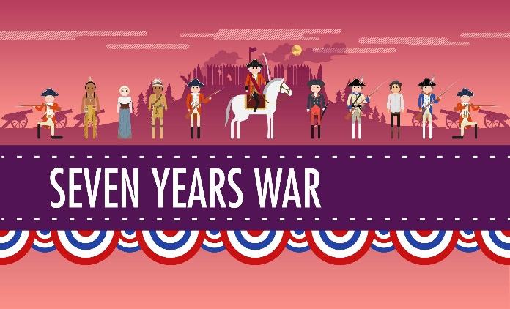
- After the 7 Years War, what resource are some English arguing for? Where is this located?
______________________________________________________________________
- What does France give up and what do they want in return?
______________________________________________________________________
______________________________________________________________________
- Who is charged with trying to govern the peace for the British? Who is his ally?
______________________________________________________________________
- What crisis was brewing for Murray? And what was his decision?
______________________________________________________________________
______________________________________________________________________
- What are English merchants pushing hard for?
______________________________________________________________________
- What was the outcome for Murray? _____________________________________

- Who is now Governor and what principal theme does he believe in?
_____________________________________________________________________

- Why does he want to keep the French happy? What is he concerned about?
______________________________________________________________________
______________________________________________________________________
- What do the colonists do in Boston to protest taxes that were imposed on them? What is then Britain’s response to this?
______________________________________________________________________
______________________________________________________________________
- What were the concessions of the Quebec Act?
______________________________________________________________________
______________________________________________________________________
______________________________________________________________________
- Why were the American colonies upset and what did this lead to?
______________________________________________________________________
______________________________________________________________________
